What is Bootstrap

* Bootstrap is the most popular HTML, CSS and JavaScript framework for developing a responsive and mobile friendly website.
* It is absolutely free to download and use.
* It is a front-end framework used for easier and faster web development.
* It includes HTML and CSS based design templates for typography, forms, buttons, tables, navigation, modals, image carousels and many others.
* It can also use JavaScript plug-ins.
* It facilitates you to create responsive designs.



### **Why use Bootstrap**

Following are the main advantage of Bootstrap:

* It is very easy to use. Anybody having basic knowledge of HTML and CSS can use Bootstrap.
* It facilitates users to develop a responsive website.
* It is compatible on most of browsers like Chrome, Firefox, Internet Explorer, Safari and Opera etc.

### **What is a responsive website**

A website is called responsive website which can automatically adjust itself to look good on all devices, from smart phones to desktops etc.

### **What Bootstrap package contains**

**Scaffolding:** Bootstrap provides a basic structure with Grid System, link styles, and background.

**CSS:** Bootstrap comes with the feature of global CSS settings, fundamental HTML elements style and an advanced grid system.

**Components:** Bootstrap contains a lot of reusable components built to provide iconography, dropdowns, navigation, alerts, pop-overs, and much more.

**JavaScript Plugins:** Bootstrap also contains a lot of custom jQuery plugins. You can easily include them all, or one by one.

**Customize:** Bootstrap components are customizable and you can customize Bootstrap's components, LESS variables, and jQuery plugins to get your own style.

### Steps to Install Bootstrap

**Step 1:**Use the below link to get bootstrap downloaded. Click on Download; the bootstrap package will be downloaded in a Zip folder. This folder contains the CSS and JS folders.

<https://getbootstrap.com/docs/4.0/getting-started/download/>

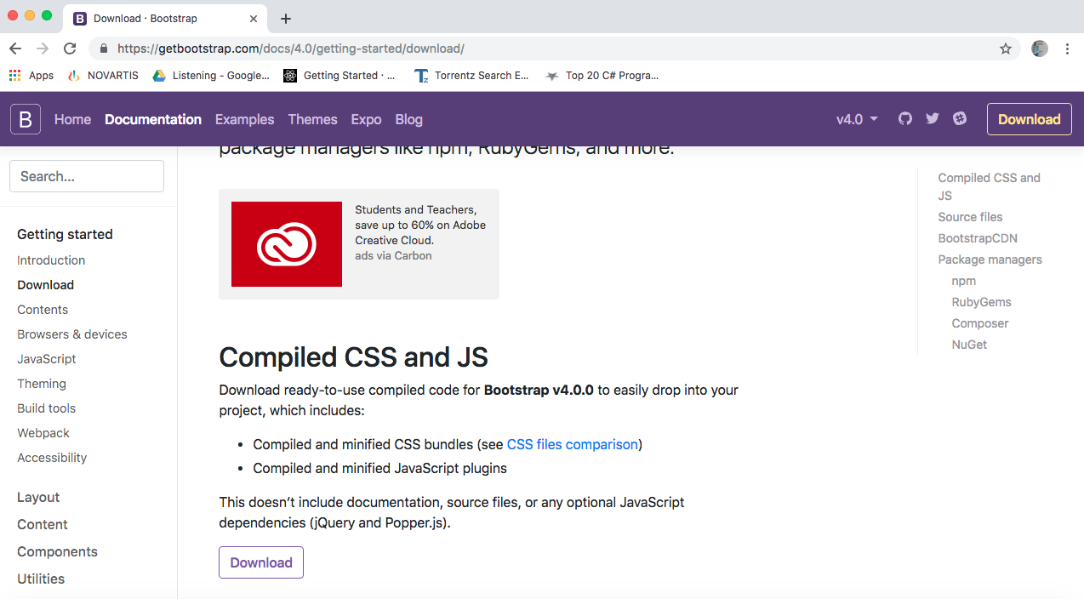

**Step 2: Source file**: Bootstrap can be compiled with its own asset pipeline with the help of javascript, sass and documentation files.

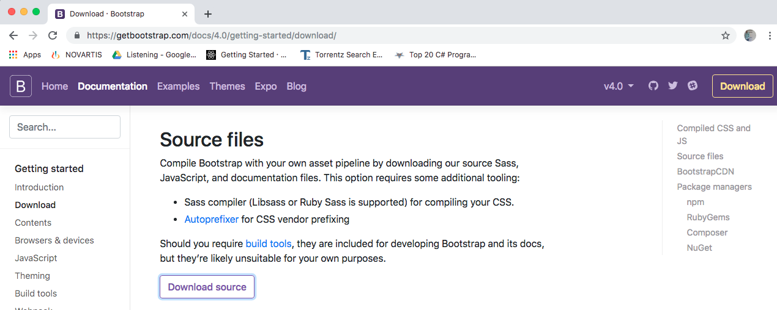

### Bootstrap File structure

* Bootstrap has been precompiled, the compiled version of bootstrap being is downloaded and extract the Zip file and the following file structure you will see:

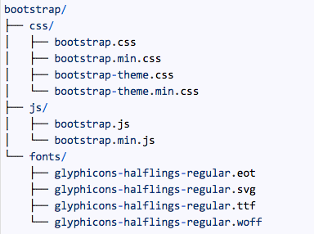

**Configuring bootstrap in web page (OR) including bootstrap inside webpage or html page**

<!DOCTYPE html>

<head>

    <link rel="stylesheet" href="bootstrap.min.css" >

    <script src="bootstrap.min.js" ></script>

</head>

<body>

    <h1> bootstrap Example</h1>

    <p> This is paragraph</p>

</body>

**(OR)**

<!DOCTYPE html>

<head>

    <link rel="stylesheet" href="https://cdn.jsdelivr.net/npm/bootstrap@4.0.0/dist/css/bootstrap.min.css" integrity="sha384-Gn5384xqQ1aoWXA+058RXPxPg6fy4IWvTNh0E263XmFcJlSAwiGgFAW/dAiS6JXm" crossorigin="anonymous">

    <script src="https://cdn.jsdelivr.net/npm/bootstrap@4.0.0/dist/js/bootstrap.min.js" integrity="sha384-JZR6Spejh4U02d8jOt6vLEHfe/JQGiRRSQQxSfFWpi1MquVdAyjUar5+76PVCmYl" crossorigin="anonymous"></script>

</head>

<body>

    <h1> bootstrap Example</h1>

    <p> This is paragraph</p>

</body>

**Note: The current version of bootstrap is bootstrap 5.0**

**Add the HTML 5 doctype:** Bootstrap uses HTML elements and CSS properties, so you have to add the HTML 5 doctype at the beginning of the page with lang attribute and correct character set.

**Ex:**

<!DOCTYPE html**>**

**<html** lang="en"**>**

**<head><meta** http-equiv="Content-Type" content="text/html; charset=

**“utf-64** "**>**

**<title>**Any title**</title>**

**</head>**

**<body>**

//write code

**</body>**

**</html>**

Mobile-first styles are part of the core framework of Bootstrap.You have to add the following <meta> tag inside the <head> element for proper rendering and touch zooming:

**<meta** name="viewport" content="width=device-width, initial-scale=1"**>**

**Note:** The **"width=device-width"**part is used to set the width of the page to follow the screen-width of the device (vary according to the devices).

The **initial-scale=1** part is used to set the initial zoom level when the page is first loaded by the browser.

**Containers:** container is used to wrap the site contents. There are two container classes.

* The**.container class** provides a responsive fixed width container.
* The **.container-fluid** class provides a full width container, spanning the entire width of the viewport.